# AI ASSISTED CODING

ASSIGNMENT 6.4

KAVALI SAI KARTHIK

2403A52043

BATCH 03

TASK 1

Start a Python class named Student with attributes name, roll_number, and marks. Prompt GitHub Copilot to complete methods for displaying details and checking if marks are above average

PROMPT - Create a Python class named Student with attributes name roll number and marks

Add a method to display the studentS details name roll number marks

Add another method to check if the student's marks are above the average pass average marks as argument Complete the implementation below

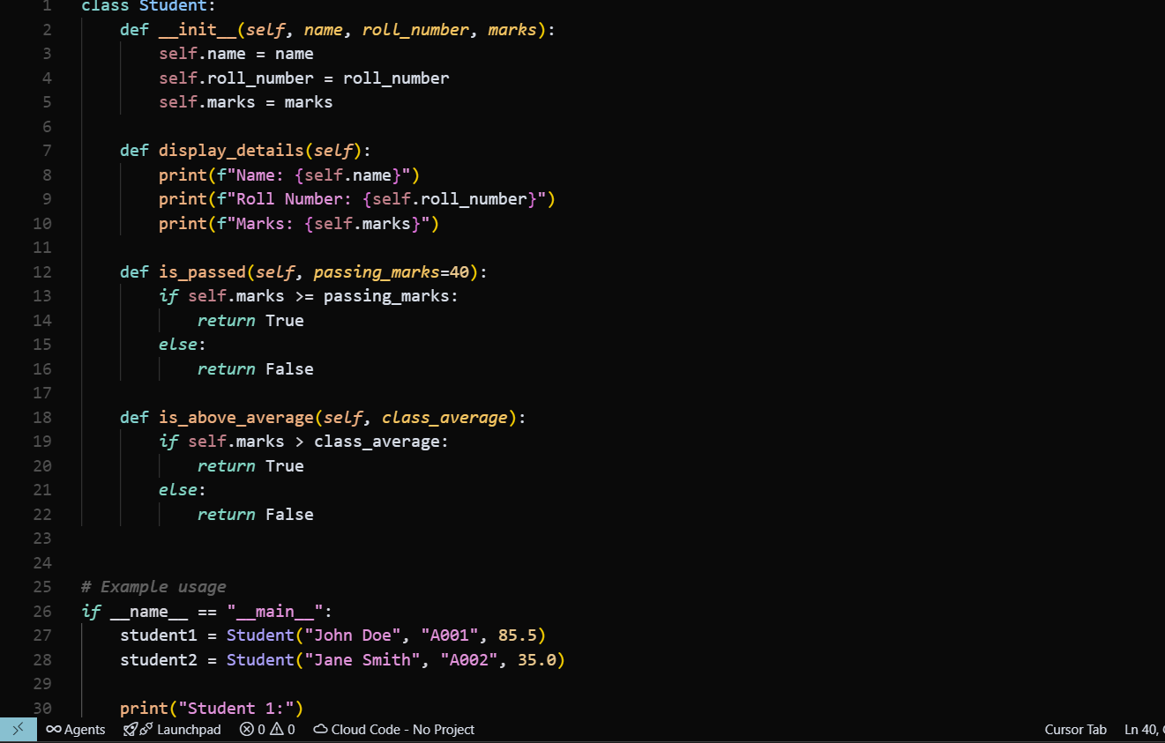

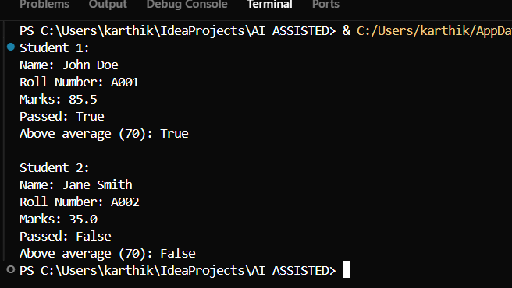

OBSERVATION

GENERATED METHODS LIKE DISPLAYING DETAILS AND CHECKING IF MARKS ARE ABOVE AVERAGE MAKE THE CLASS PRACTICAL AND EASY TO USE . THE CODE IS STRAIGHT FORWARD AND DEMONSTRATE BASIC OBJECT OREIENTED PROGRAMMING AND CONDITIONAL CHECKS .

TASK – 2

Write the first two lines of a for loop to iterate through a list of numbers. Use a comment prompt to let Copilot suggest how to calculate and print the square of even

numbers only.

PROMPT - Check if the number is even, then calculate its square and print it

CODE

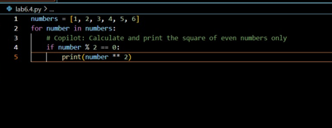



OBSERVATION –

This task demonstrates how to use a for loop to iterate through a list of numbers and apply conditional logic to process only even numbers. By including a comment prompt, Copilot can suggest code to calculate and print the square of even numbers, making the code concise and easy to understand.

TASK – 3

Create a class called BankAccount with attributes account_holder and balance. Use Copilot tocomplete methods for deposit(), withdraw(), and check for insufficient balance

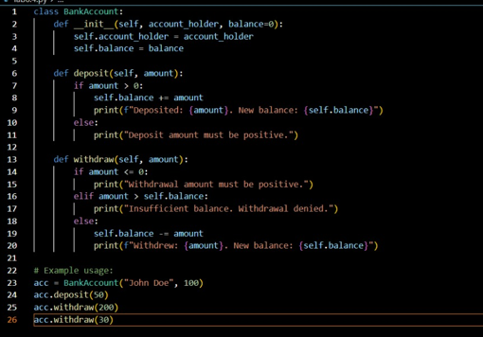

OUTPUT –



OBSERVATION –

THE BANK ACCOUNT CLASS LETS YOU DEPOSIT AND WITHDRAW MONEY AND CHECKS FOR INSUFFICIENT BALANCE BEFORE WITHDRAWING . THE CODE IS SIMPLE AND EASY TO UNDERSTAND

TASK – 4 DEFINE A LIST OF STUDENT DICTIONARIES WITH KEYS NAME AND SCORE ASK COPOILOT TO WRITE A WHILE LOOP TO PRINT THE NAMES OF STUDENTS WHO SCORED MORE THAN 75

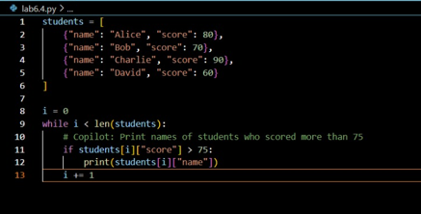



OBSERVATION –

A LIST OF STUDENT DICTONARIES STORES EACH STUDENTS NAME AND SCORE THE WHILE LOOP CHECKS EACH STUDENTS AND PRINTS THE NAME OF THOSE WHO SCORED MORE THAN 75 THE CODE IS SIMPLE AND USE BASICS LIST AND LOOP CONCEPTS.

TASK -5

BEGIN WRITING A CLASS SHOPPING CART WITH AN EMPTY ITEMS PROMPT Copilot to generate methods to add_item, remove_item, and use a loop to calculate the total bill using conditional discounts.

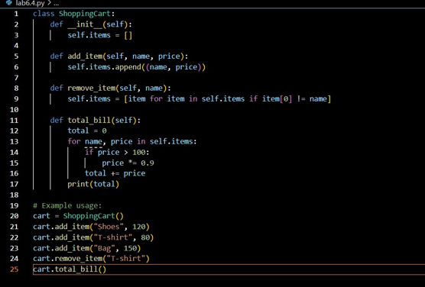

OUTPUT





OBSERVATION –

The ShoppingCart class starts with an empty items list. It has methods to add and remove items, and uses a loop to calculate the total bill. If an item costs more than 100, a discount is applied. The code is simple and shows basic class and loop usage.

END